

LAB EXPERIMENT RECORD
SET 26

Department | Artificial Intelligence and Data Science
Course Code / Course Name | DSA0601 / Data Handling and Visualization
Name / Register Number | ROHAN P T / 192424112
Date / Day | 20/10/2026

Aim
To analyze student performance analysis using the requested visualizations and dashboard views.

Dataset
Student Performance Analysis
Student_ID | Gender | Study_Hours | Attendance | Math_Score | Science_Score | Exam_Date
S01 | Male | 2.0 | 78 | 62 | 65 | 2025-01-10
S02 | Female | 3.5 | 90 | 80 | 85 | 2025-01-10
S03 | Male | 1.5 | 70 | 55 | 58 | 2025-02-12
S04 | Female | 4.0 | 95 | 90 | 92 | 2025-02-12
S05 | Male | 2.8 | 85 | 72 | 74 | 2025-03-15
S06 | Female | 3.0 | 92 | 82 | 86 | 2025-03-15

R Data Setup
Run this setup once before the R programs below. The dataset is defined inline so each record can be copied and run without a separate CSV file.
R data setup
dat <- data.frame(
Student_ID = c("S01", "S02", "S03", "S04", "S05", "S06"),
Gender = c("Male", "Female", "Male", "Female", "Male", "Female"),
Study_Hours = c(2.0, 3.5, 1.5, 4.0, 2.8, 3.0),
Attendance = c(78, 90, 70, 95, 85, 92),
Math_Score = c(62, 80, 55, 90, 72, 82),
Science_Score = c(65, 85, 58, 92, 74, 86),
Exam_Date = c("2025-01-10", "2025-01-10", "2025-02-12", "2025-02-12", "2025-03-15", "2025-03-15")
)
dat$Exam_Date <- as.Date(dat$Exam_Date)

PROGRAM 1: Student Score Distributions
Import the student data. Create a Math_Score histogram and Science_Score boxplot by gender; label the plots and interpret the results.
R code
par(mfrow=c(1,2))
hist(dat$Math_Score, col="skyblue3", xlab="Math score", main="Math Score Distribution")
boxplot(Science_Score ~ Gender, data=dat, col=c("#276B9A","#1D8790"), xlab="Gender", ylab="Science score", main="Science Scores by Gender")

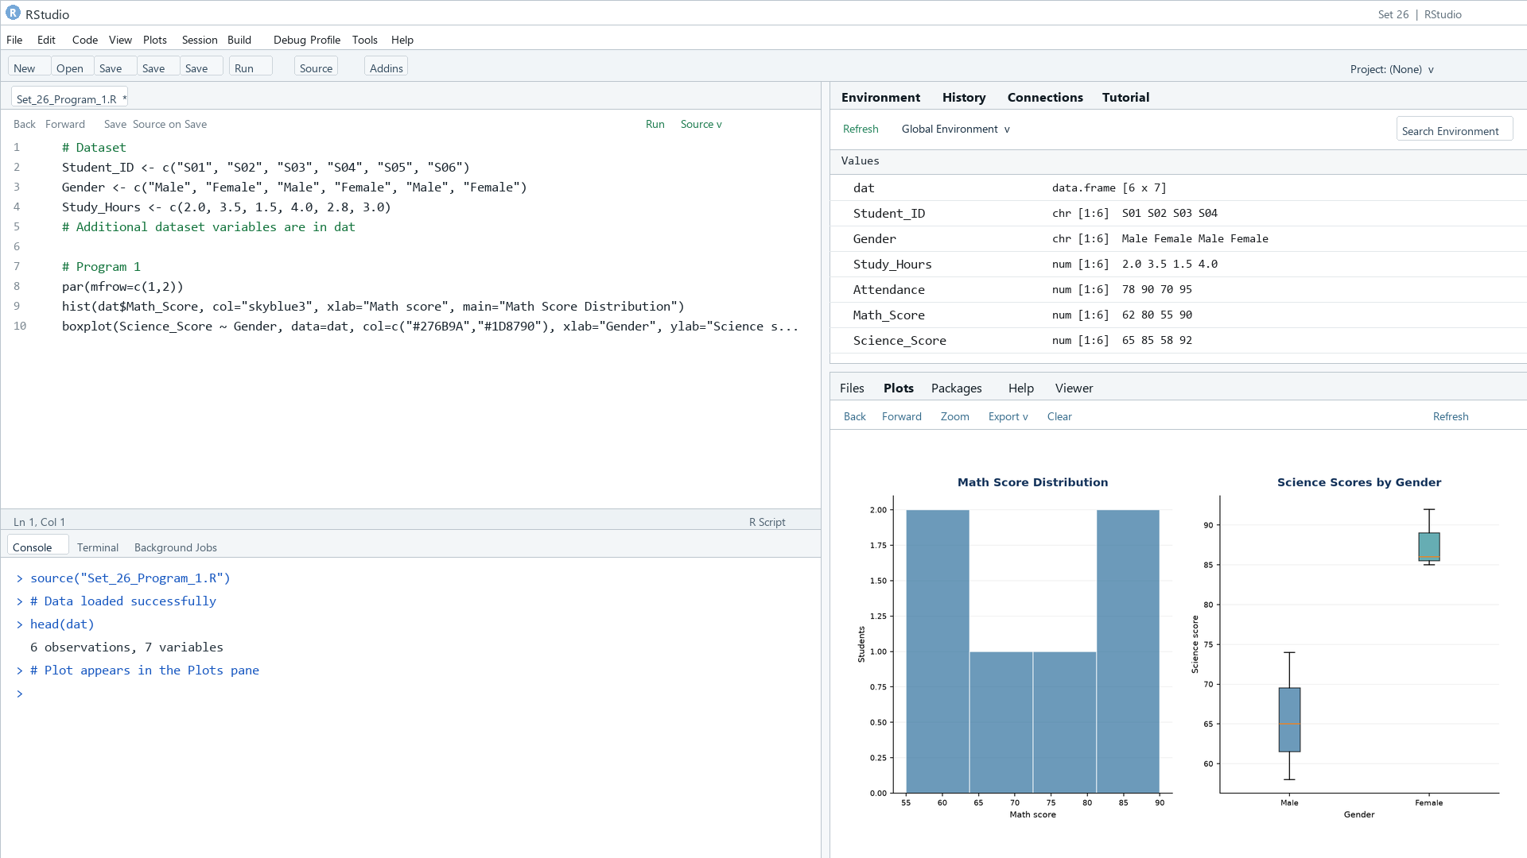
Output 1: Student Score Distributions
Observation: Female students have higher average scores in this small sample; the histogram shows the Math_Score spread across all six students.

PROGRAM 2: Study Hours and Math Performance
Create a scatter plot of Study_Hours and Math_Score, color points by gender, add a regression line, and explain the relationship.
R code
plot(dat$Study_Hours, dat$Math_Score, pch=19, col=as.factor(dat$Gender), xlab="Study hours", ylab="Math score", main="Study Hours vs Math Score")
abline(lm(Math_Score ~ Study_Hours, data=dat), col="#E68A36", lwd=2)
legend("topleft", legend=levels(as.factor(dat$Gender)), col=seq_along(levels(as.factor(dat$Gender))), pch=19, bty="n")

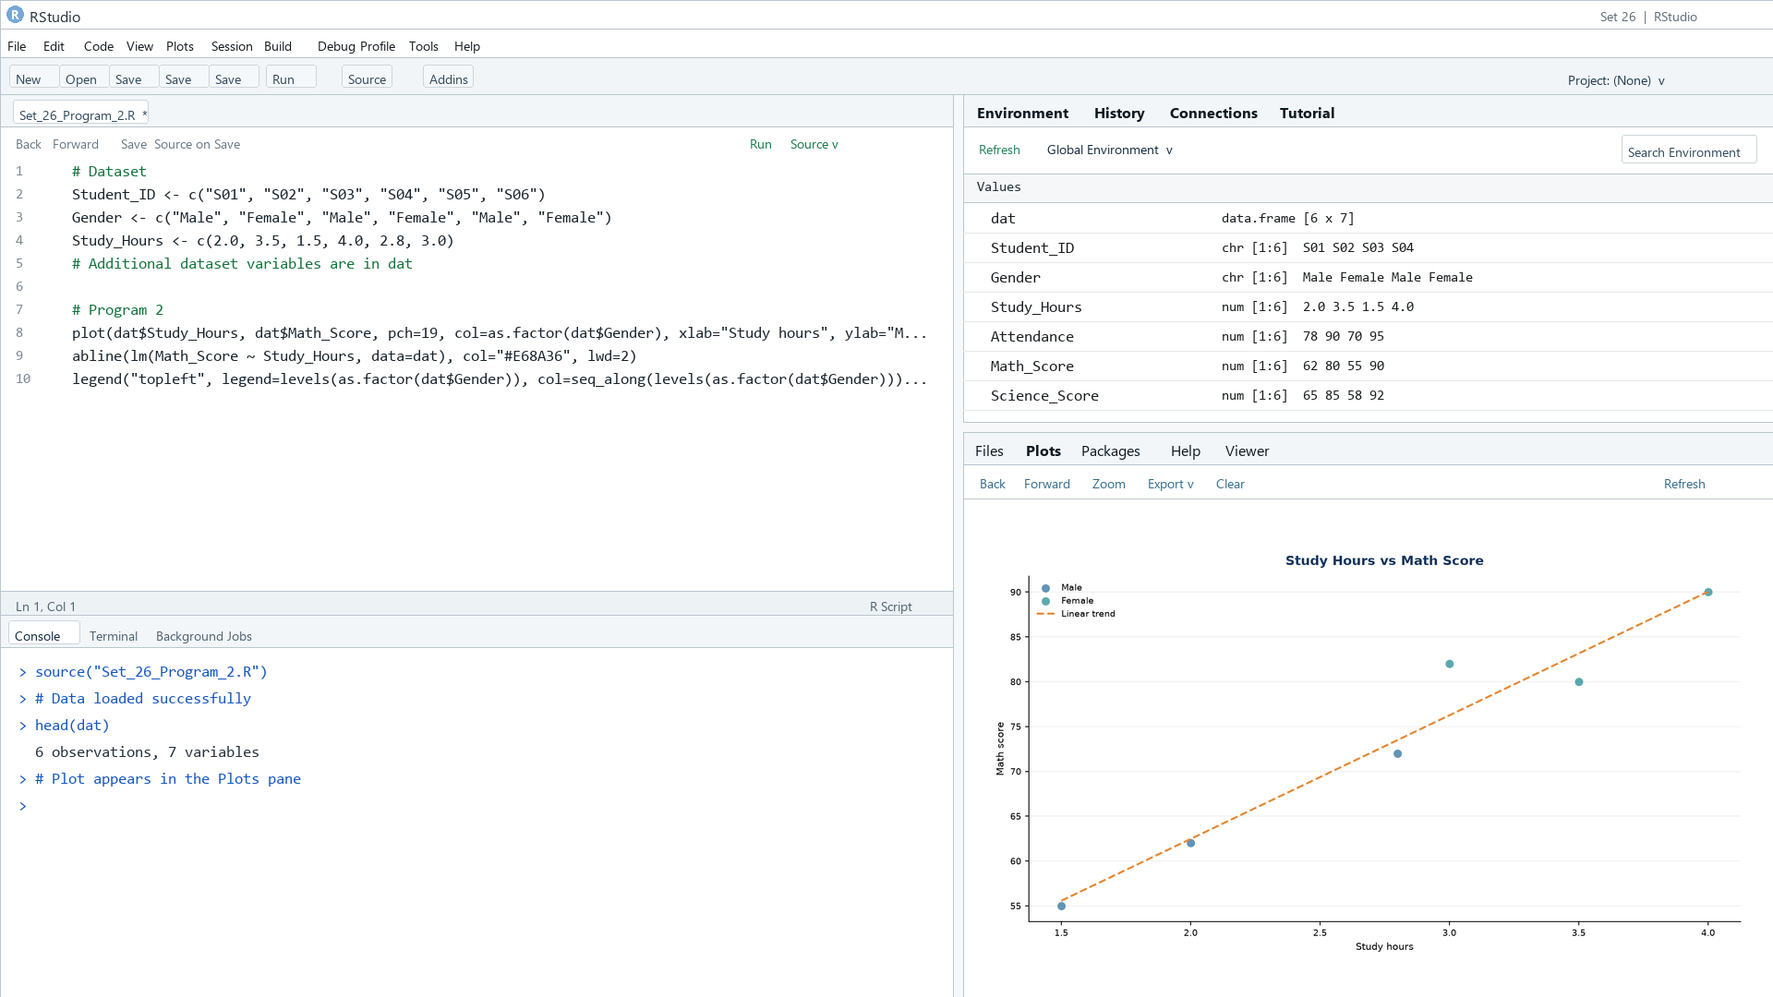
Output 2: Study Hours and Math Performance
Observation: The sample shows a positive association between study hours and Math scores; the regression line is descriptive for six records.

PROGRAM 3: Monthly Math Score Trend
Convert Exam_Date to Date, calculate monthly average Math scores, and plot a trend with moving-average smoothing.
R code
dat$Exam_Date <- as.Date(dat$Exam_Date)
dat$Month <- format(dat$Exam_Date, "%Y-%m")
avg <- aggregate(Math_Score ~ Month, dat, mean)
avg$Moving_Avg <- stats::filter(avg$Math_Score, rep(1/2,2), sides=1)
plot(avg$Math_Score, type="o", xaxt="n", xlab="Month", ylab="Average Math score", main="Monthly Average Math Score")
axis(1,1:nrow(avg),avg$Month); lines(avg$Moving_Avg, type="o", col="#E68A36")

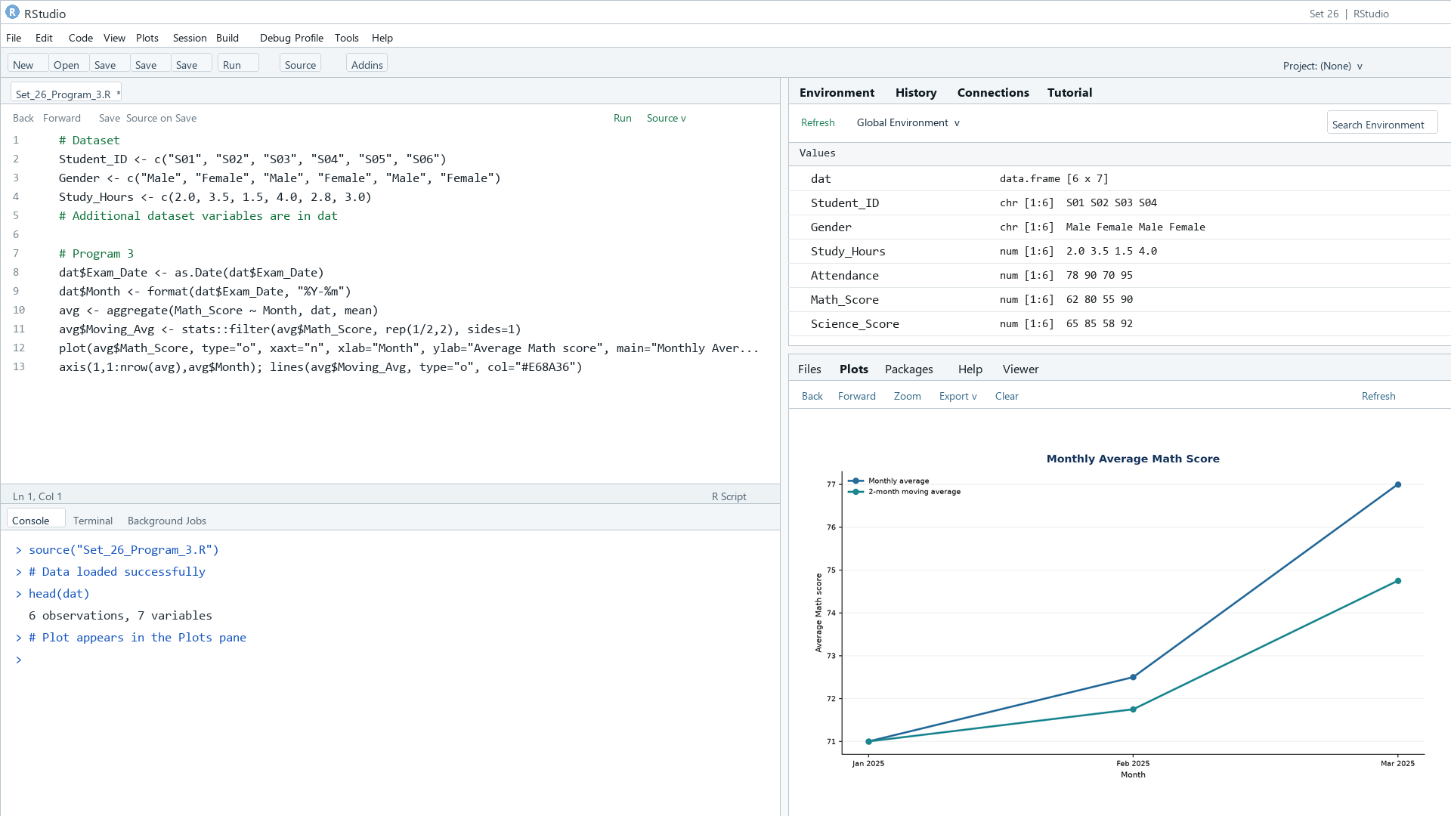
Output 3: Monthly Math Score Trend
Observation: Monthly average Math scores rise from 71.0 in January to 77.0 in March; the moving average smooths the increase.

PROGRAM 4: Student Score Dashboard
Create a Tableau dashboard with average Math score by gender and score trends over time; add an Exam_Date filter.
Tableau build steps
Tableau dashboard build
1. Connect to Student_Mini_Data.csv or enter the displayed records.
2. Create a bar chart of AVG(Math_Score) by Gender.
3. Create a line chart of AVG(Math_Score) by Exam_Date month.
4. Add Exam_Date as a filter and combine both sheets on a dashboard.

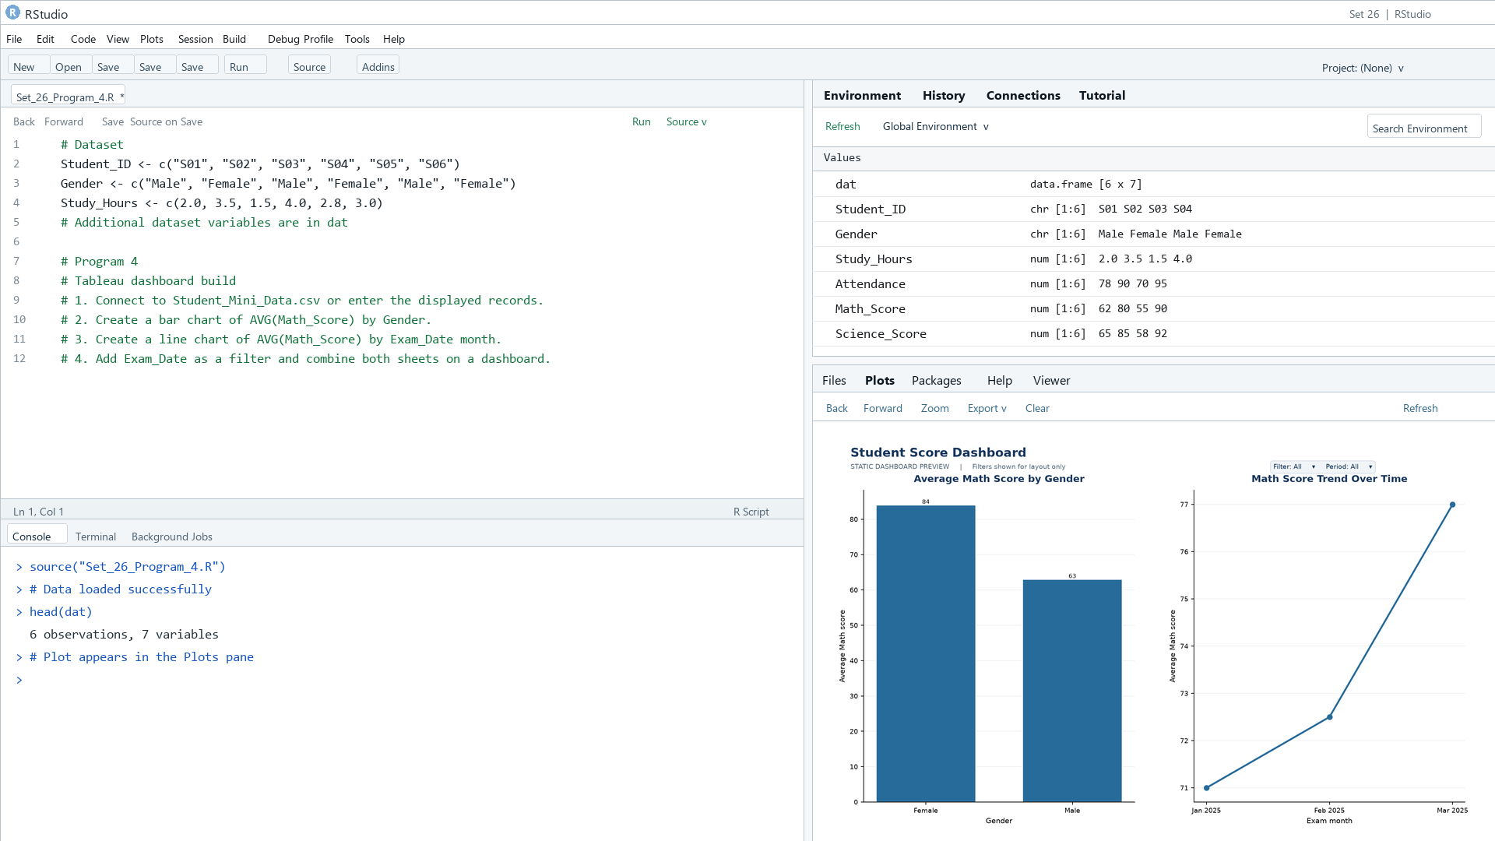
Output 4: Student Score Dashboard
Observation: The preview shows gender averages and the monthly score trend; the Exam_Date filter can narrow both sheets.

Procedure
1. Review the dataset table and confirm any illustrative fields noted in the record.
2. Run the R setup block once, then run the requested program code.
3. Compare the output screenshot with the observation and replace illustrative values when actual data is available.
4. For Tableau tasks, connect to the displayed data and follow the dashboard build steps.

Result
The requested charts and dashboard views for Set 26 were prepared from the displayed dataset. Outputs include labels, short observations, and code or dashboard construction steps.

Key Functions Used
plot(), barplot(), hist(), boxplot(), table().

